Agenda
- Demo of Medplum provider, to show how PlanDefinitions are applied with Questionnaires, ServiceRequests, and Tasks
- Map flows of these PlanDefinitions to tenancy hierarchy (across all Openloop, relevant to one vertical, relevant to one client)
(with extra time)
- Review with Tonda the proposal on how to allow for client-edited intake forms

Prerequisites
- Read CarePlan diagram below, and initial mapping of CarePlans to care journey document

Deliverable for this session
- Map CarePlan templates to tenancy hierarchy

Action Items
- [Ongoing] Implement the two customers’ organizations and questionnaires into the above mapping

Outstanding Questions
- Separate out tenancy and auth across orgs (David)
  - Each client will have its own Organization
  - Verticals represented by a HealthcareService (GLP-1s, TRT, etc)

Clinical Protocol Template Hierarchy

Across Openloop
- (?) Payment Questionnaire

Across Vertical
- Patient Intake Questionnaire
- Practitioner Charting Questionnaire

Single Customer
- (?) Payment Questionnaire
- Available Labs (as part of Charting Questionnaire)
- Available Prescriptions (as part of Charting Questionnaire)

Purpose of PlanDefinition
- Convert implicit business logic into FHIR resource data
  - Normally, codes implies business logic
    - “When the status of X is done, codes does Y if this, code does Z if this”
  - PlanDefinitions force you to explicitly delineate your business logic, in a way that is editable by non-technical staff
    - “When the status of X is done, instantiate these Y, Z from the data”

Materials
- FHIR PlanDefinition$apply: https://build.fhir.org/plandefinition-operation-apply.html
- Sample PlanDefinition: https://www.medplum.com/docs/provider/visits#how-to-set-up-a-care-template

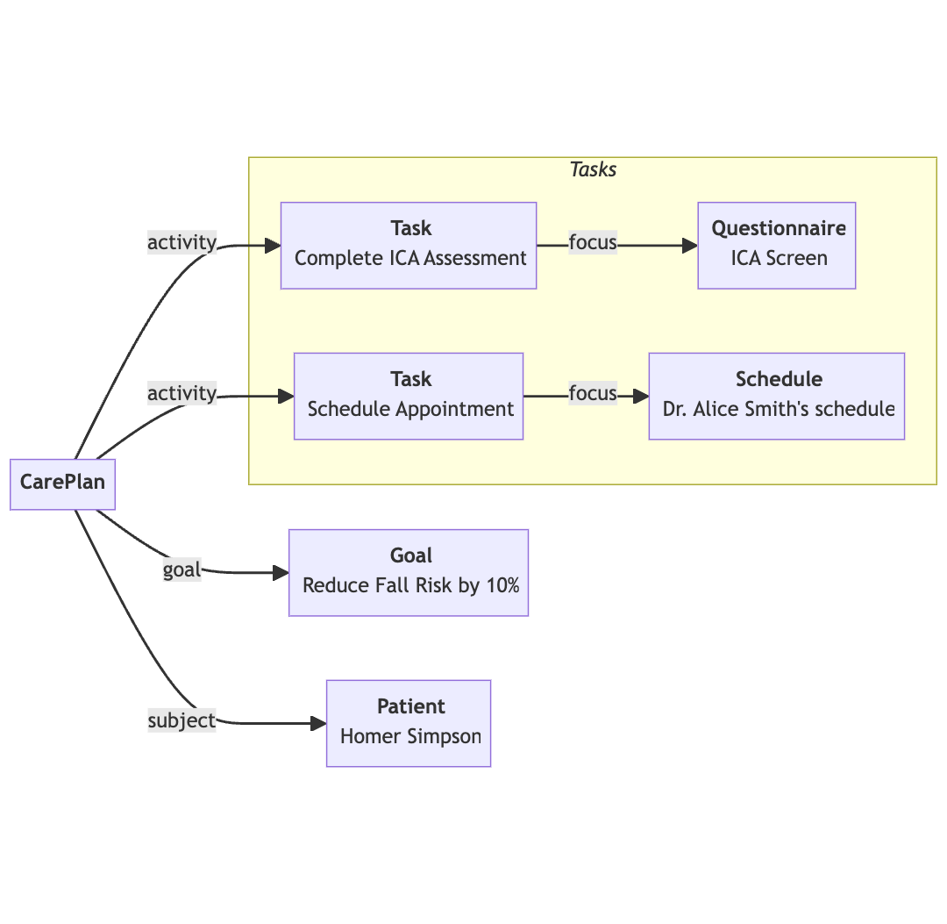

Child CarePlans

INTAKE AND PAYMENT CAREPLAN
Goal: Intake patient
Activities:
Initial Intake (activities
- Patient intake: create Task, assigned to Patient, to complete Questionnaire
  - Instantiates a QuestionnaireResponse
- Consent: our Provider app includes an example of a Questionnaire with Consent
Payment (activities)
- Patient selects Rx: create Task, assigned to Patient to complete Questionnaire
  - Instantiates a QuestionnaireResponse, with the menu of Rx items available to them via the client’s specifications
- Upon completion of selection and payment:
  - Payment succeeds: triggers webhook, that then sets the subscription info in Stripe
  - Payment fails: (another PlanDefinition$apply) create Task, assigned to billing team, to reach out to patient. DO NOT apply next CarePlan. Can instantiate a Communication resource here
Patient Created (activities)
- Parse QuestionnaireResponse from Initial Intake to relevant FHIR resources

INITIAL VISIT (SYNC) CAREPLAN
Goal: Set up and complete first visit with patient
Activities:
Patient Created (activities)
- Encounter note: create Task, assigned to Practitioner, to complete Charting Questionnaire
  - Instantiates a QuestionnaireResponse
  - Can do charting pre-fill at this step, since QuestionnaireResponse is instantiated
Scheduling (activities)
- Scheduling: create Task, assigned to Patient, to book an Appointment (see docs on Scheduling)
Initial Visit (activities)
- During visit, Practitioner edits and signs the QuestionnaireResponse

  - Signs note: We have a SignatureInput component, with examples of usage in our repo

LABS CAREPLAN (applied if Charting QuestionaireResponse has labs selected)
Labs (activities)
- Create Task, assigned to Patient, to go get labs done
- Create ServiceRequest, posted to Junction/labs partner, that represents the lab order

RX CAREPLAN (applied based on responses in Charting QuestionnaireResponse)
Rx Order/Fulfillment
- Create MedicationRequest, posted to Dosespot/Photon/prescribing partner, that represents the prescription order
- (possibly) create MedicationDispense, used to log tracking information about package if relevant
- Create Task, assigned to clinical ops team, to follow up with Patient regarding prescription (mark as draft initially, then mark as ready when patient fills prescription)

Refill architecture

